**Database Administration homework**

1. Download MySQL server for your OS on VM &&  
2. Install MySQL server on VM.

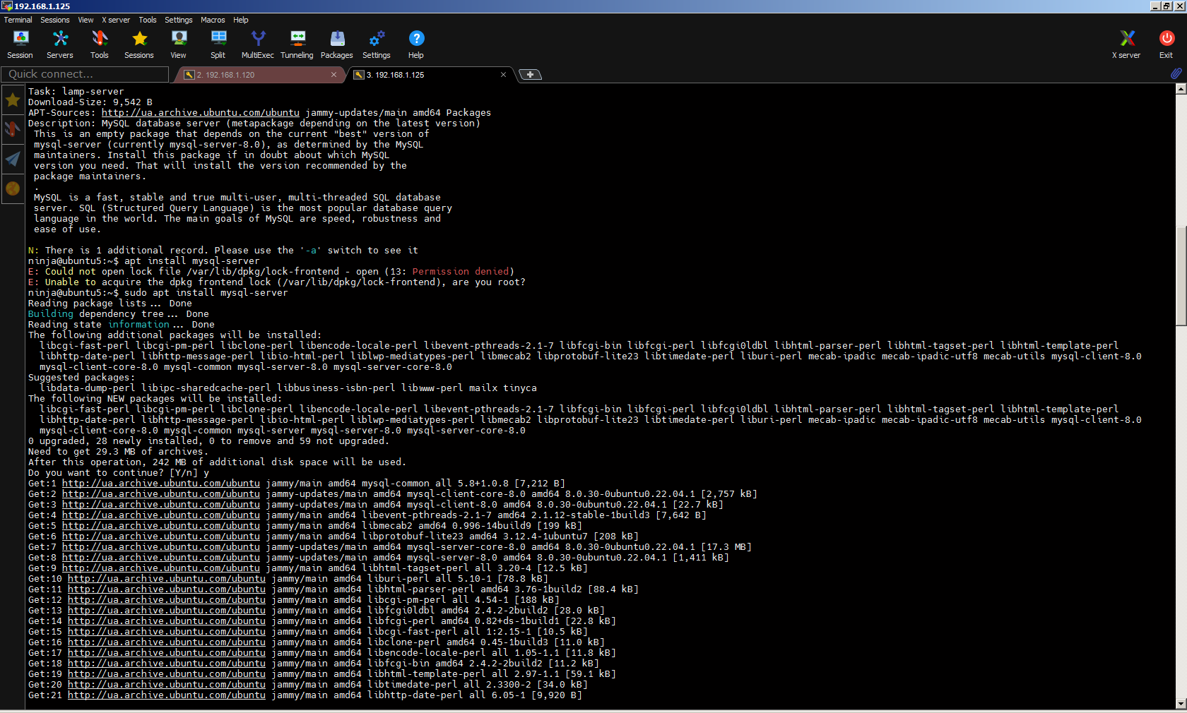

3. Select a subject area and describe the database schema, (minimum 3 tables)

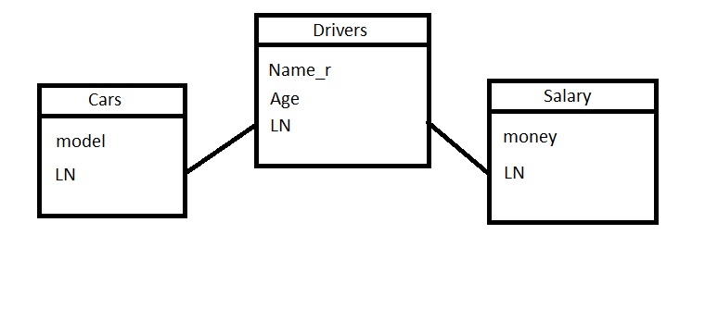4. Create a database on the server through the console

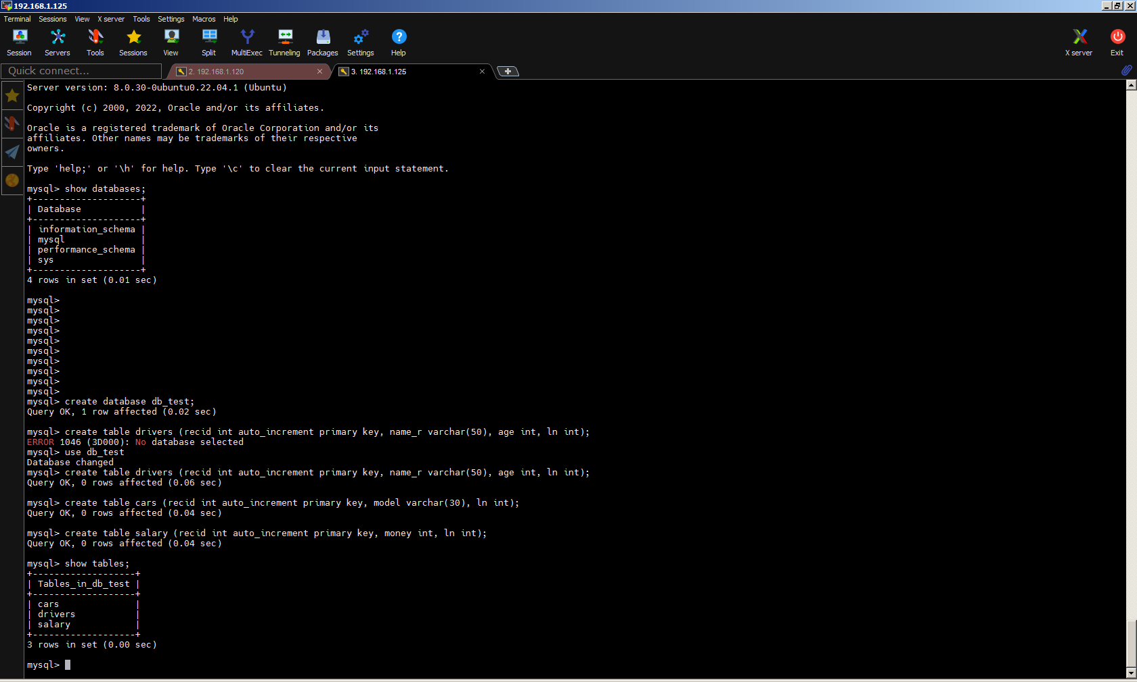

5. Fill in tables.

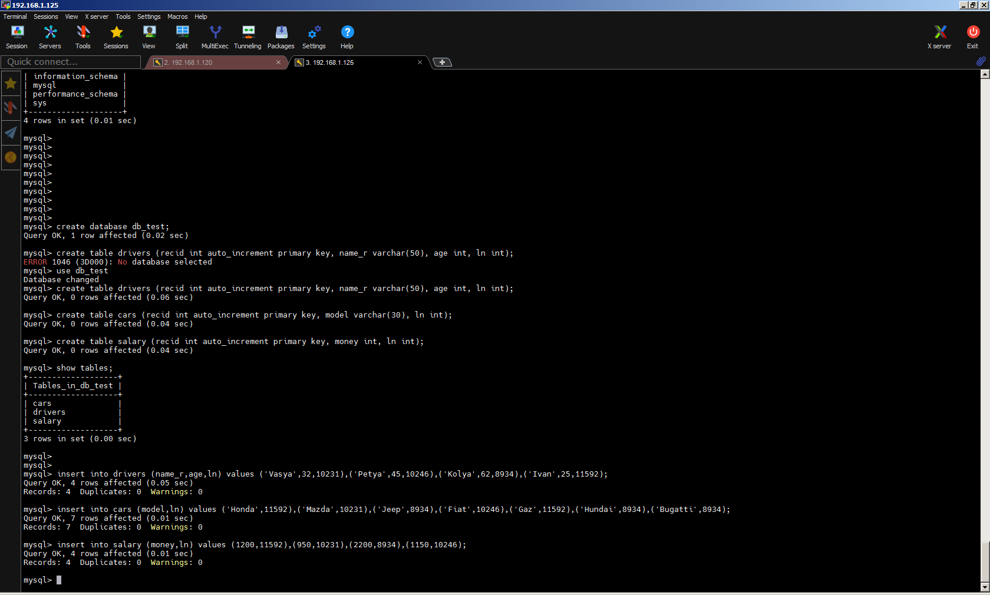

6. Construct and execute SELECT operator with WHERE, GROUP BY and ORDER BY.

select d.name_r, c.ln, count(*) count_of_cars from cars c, drivers d where d.ln=c.ln group by d.name_r,c.ln order by count_of_cars desc;

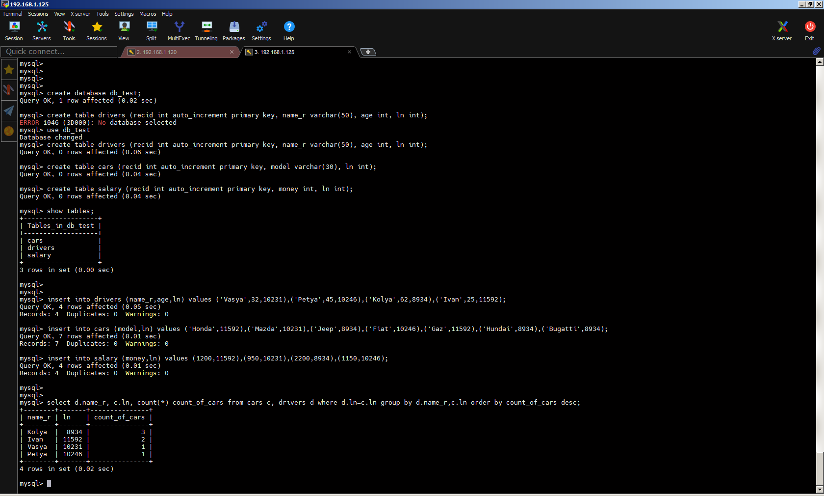

7. Execute other different SQL queries DDL, DML, DCL

ddl: CREATE USER 'dbuser'@'localhost' IDENTIFIED BY 'secret';

dml: delete from cars where recid = '27';

dcl: GRANT ALL ON db_test.* TO 'dbuser'@'localhost';

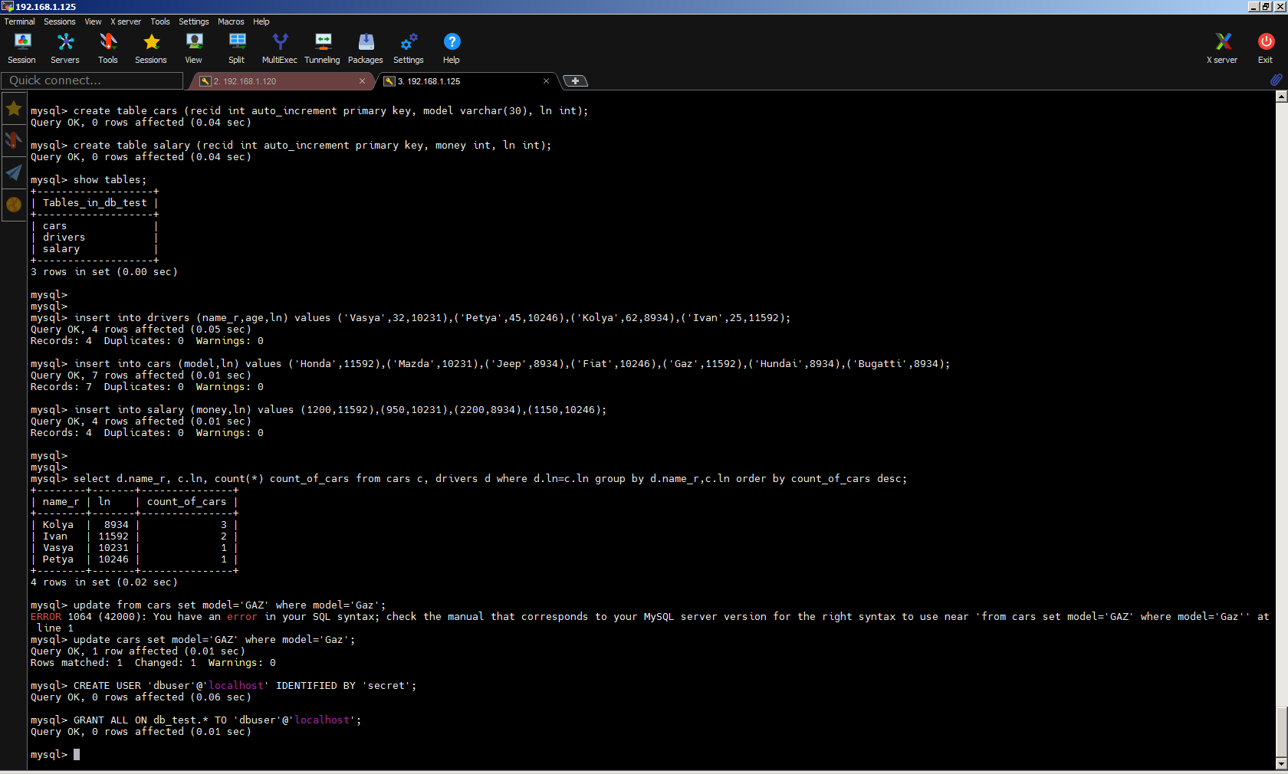

8. Create a database of new users with different privileges. Connect to the  
database as a new user and verify that the privileges allow or deny certain  
actions.



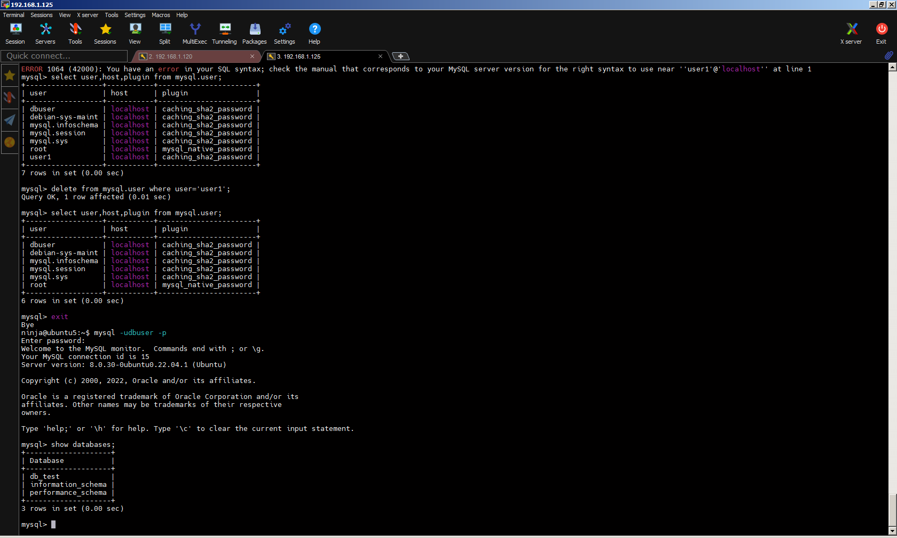

9. Make a selection from the main table DB MySQL.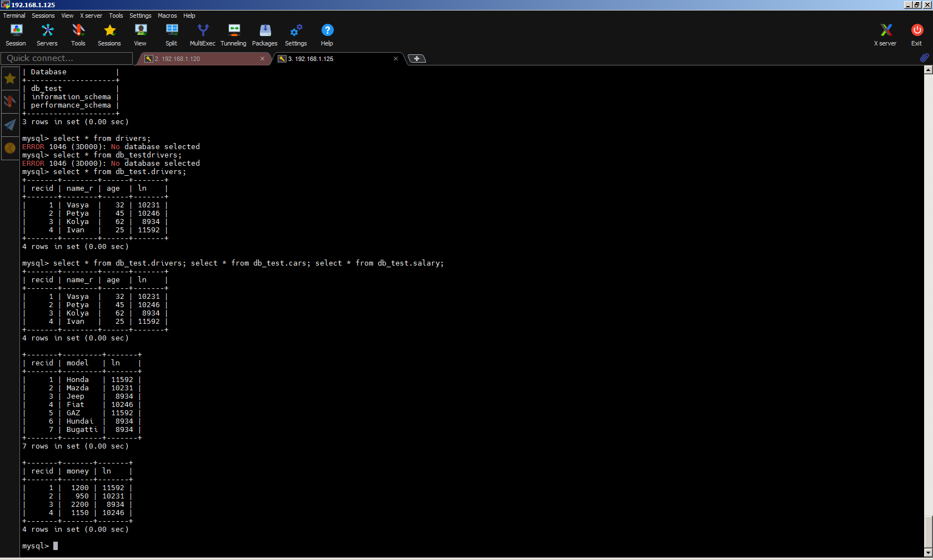

10.Make backup of your database.

mysqldump -uroot -p --databases db_test > db_test.sql

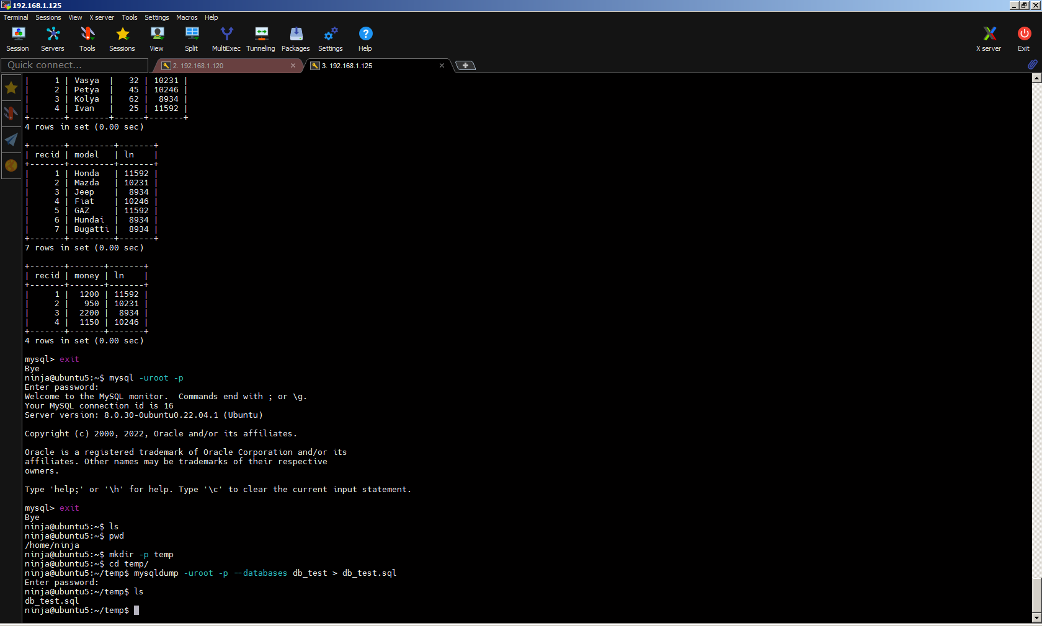

11.Delete the table and/or part of the data in the table &&  
12.Restore your database.

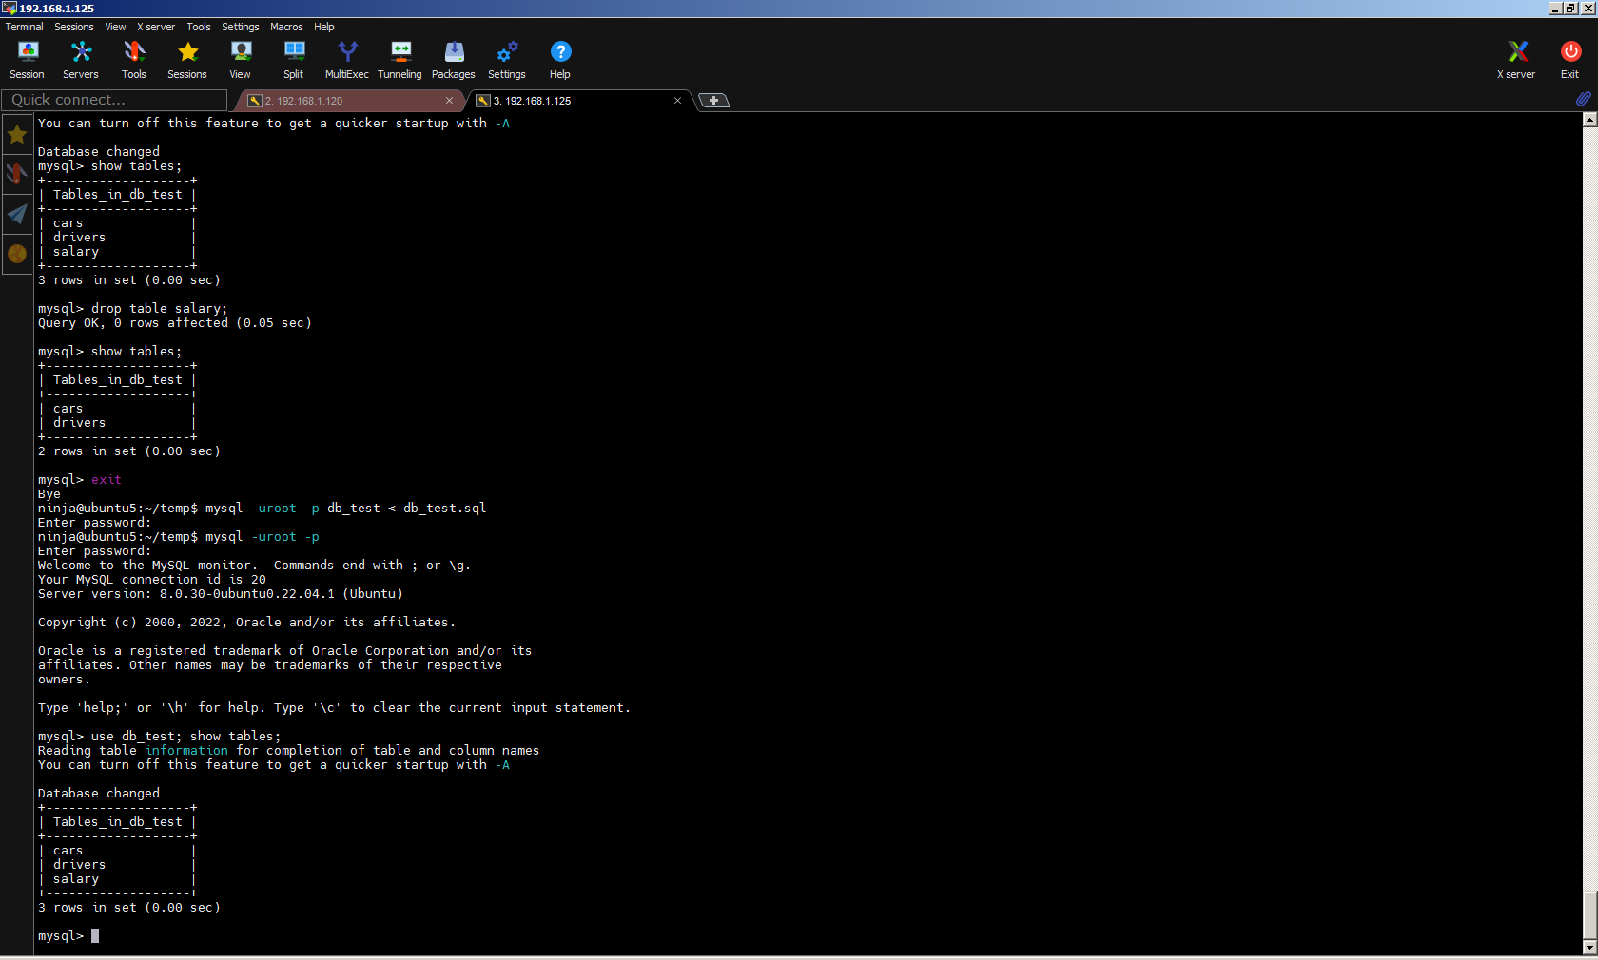

13.Transfer your local database to RDS AWS &&  
14.Connect to your database.

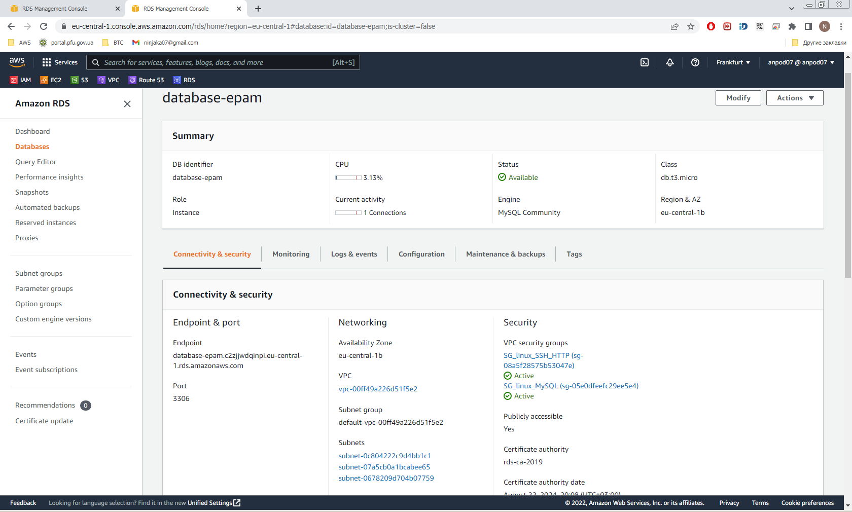

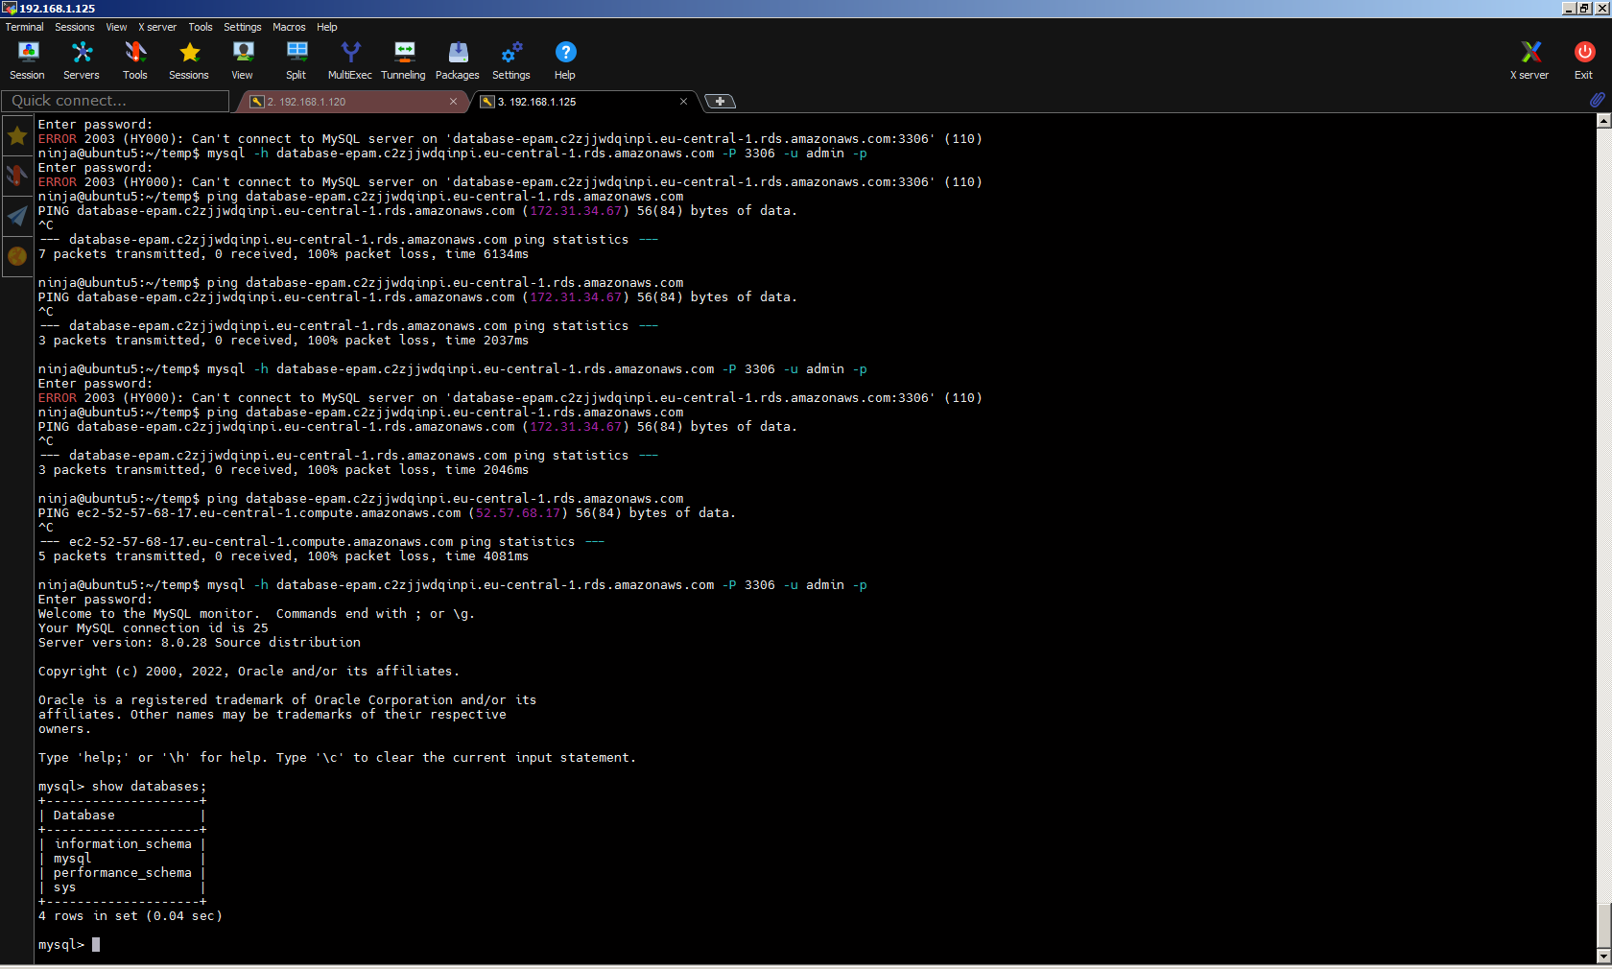

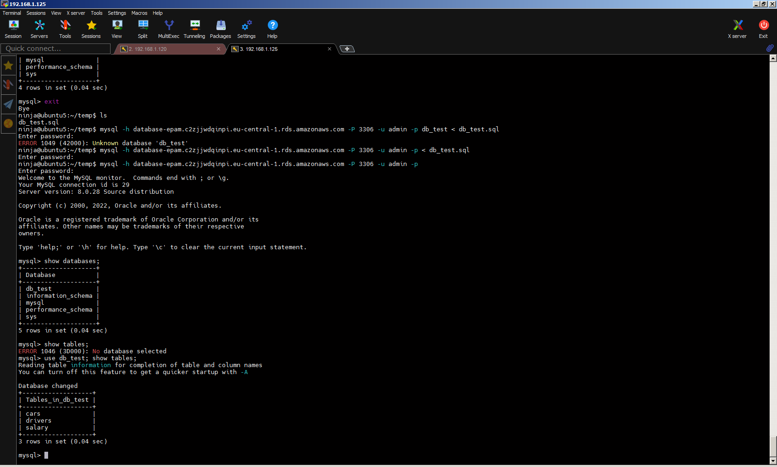

15.Execute SELECT operator similar step 6.

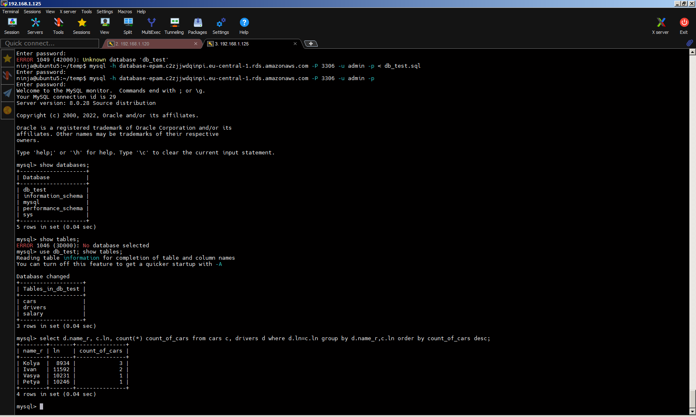

16.Create the dump of your database.

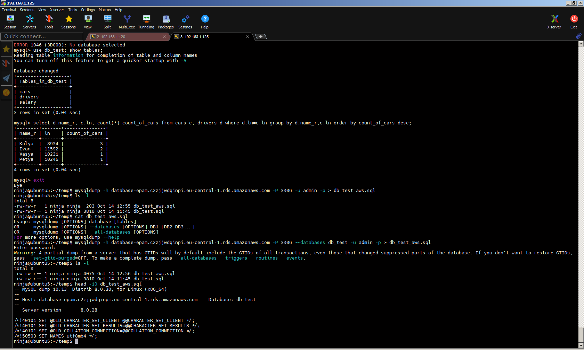

17. Create a database. Use the use command to connect to a new database (If it  
doesn't exist, Mongo will create it when you write to it).

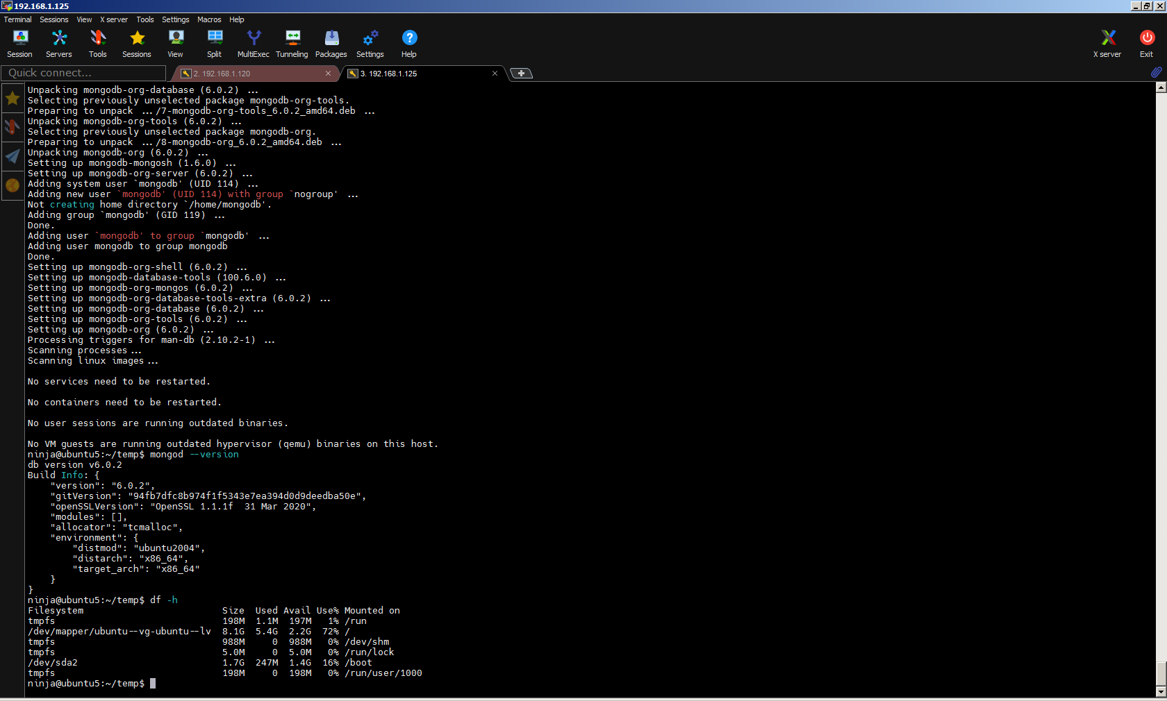 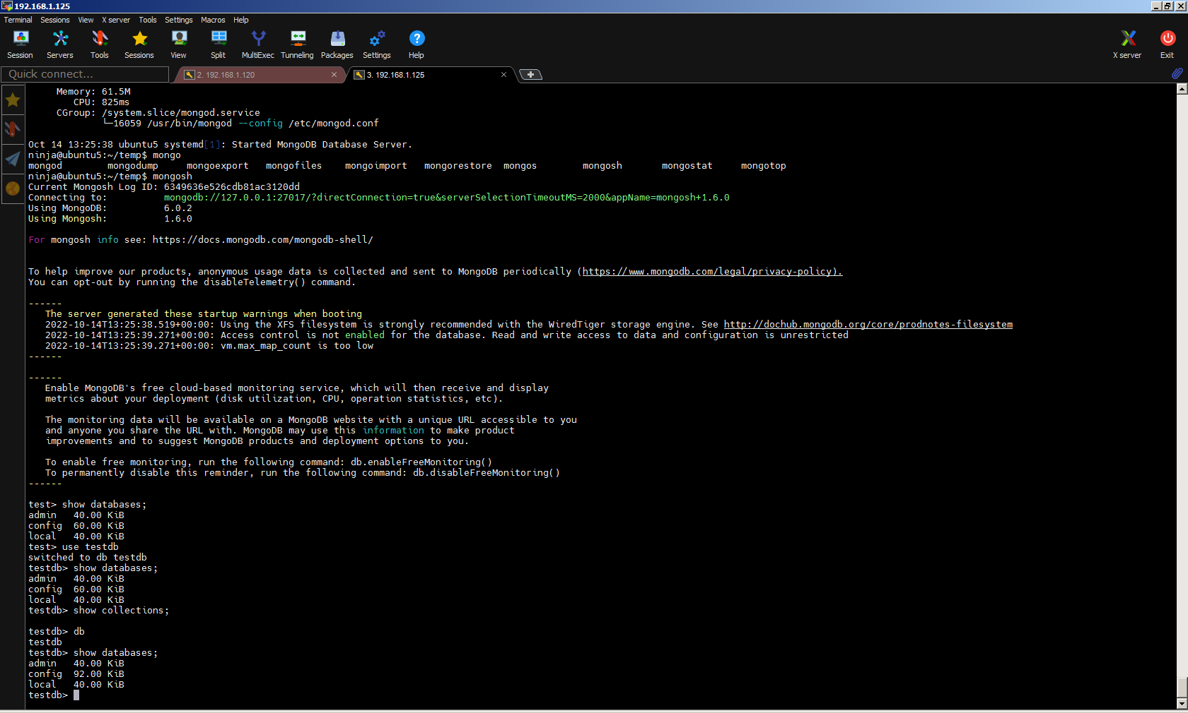  
18. Create a collection. Use db.createCollection to create a collection. I'll leave the  
subject up to you. Run show dbs and show collections to view your database and

collections.

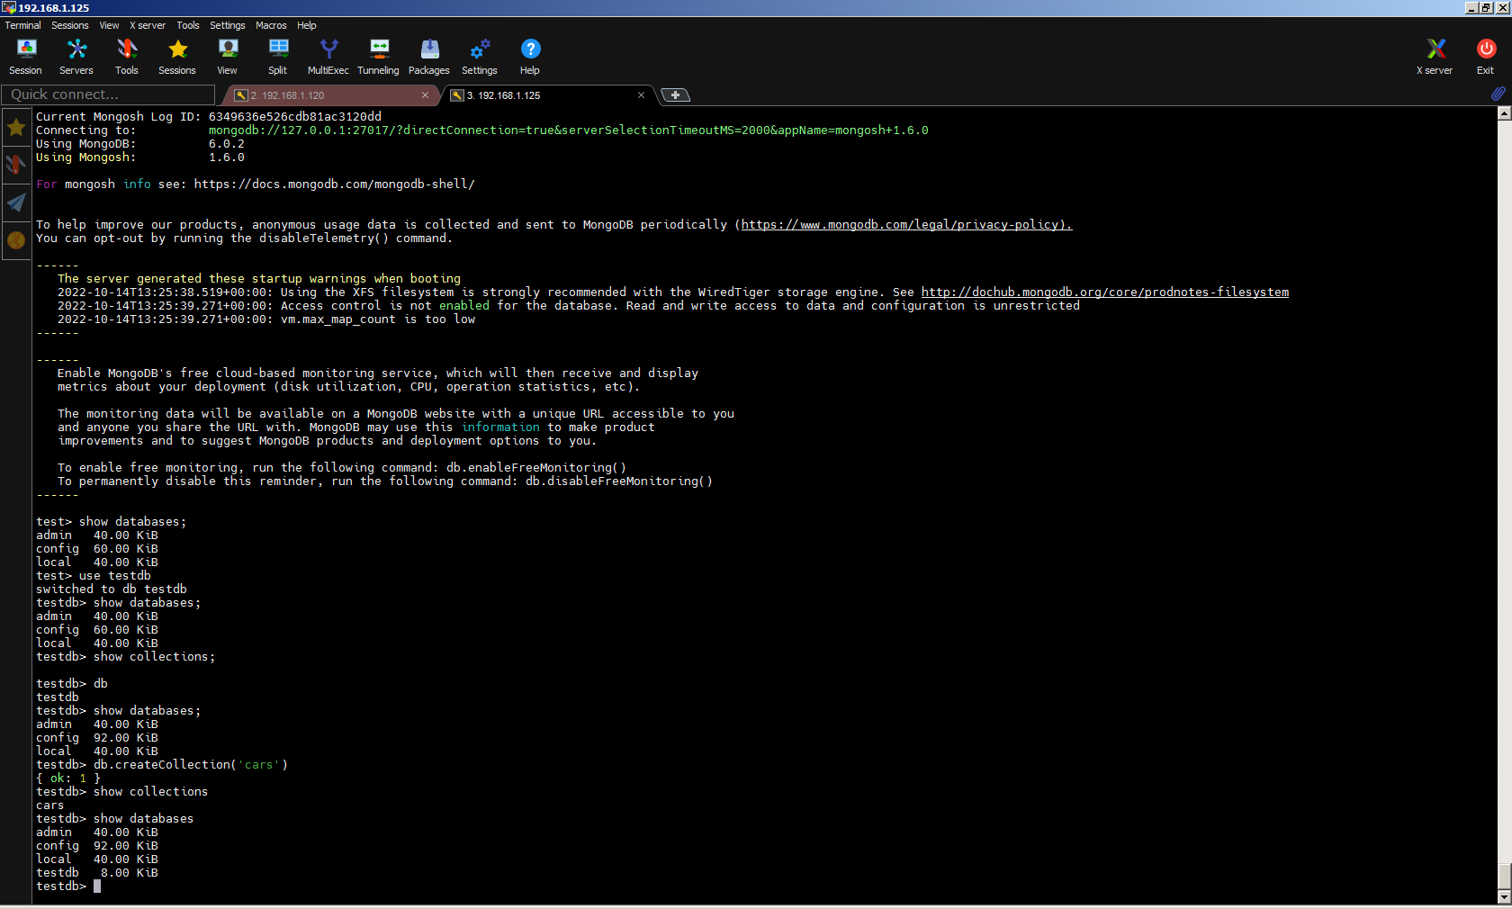  
19. Create some documents. Insert a couple of documents into your collection. I'll  
leave the subject matter up to you, perhaps cars or hats.

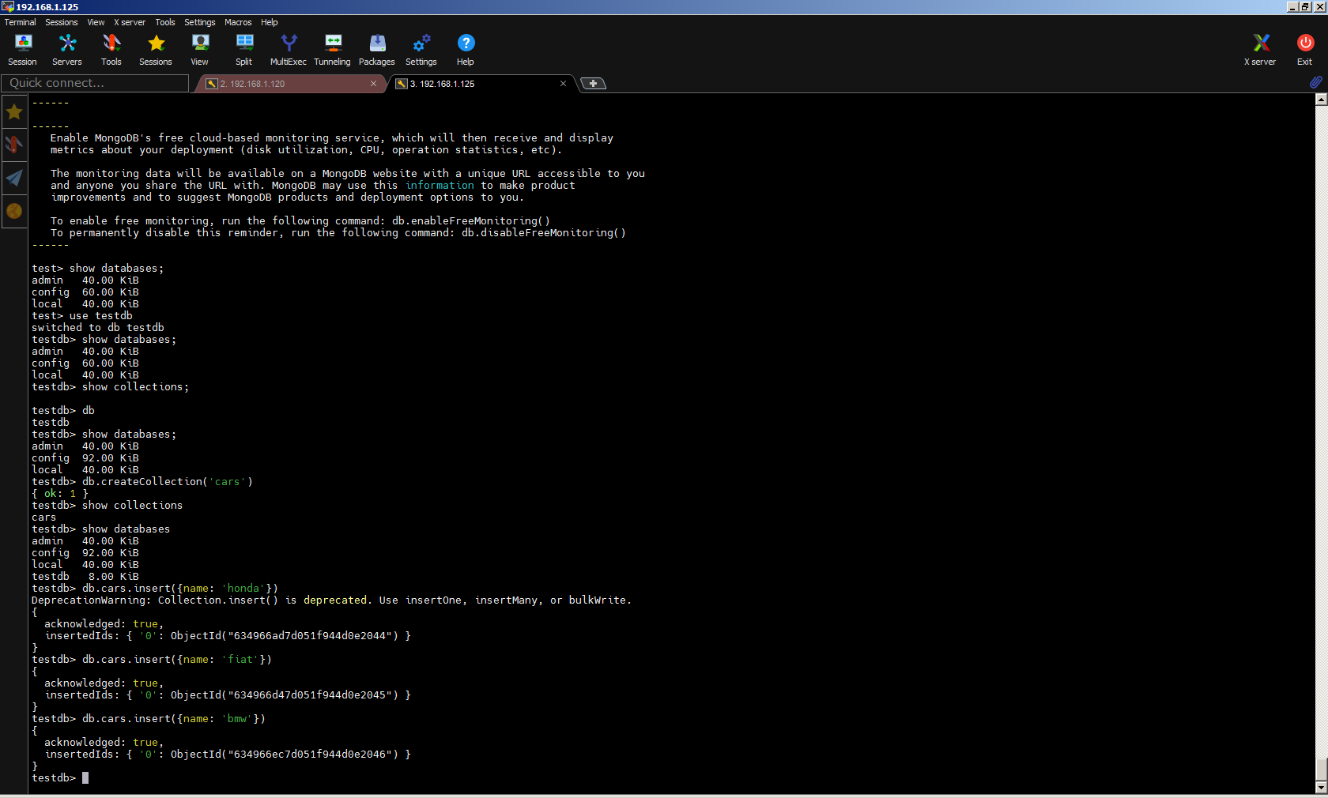

20. Use find() to list documents out.

